**SIT 725**

**Applied Software Engineering**

**Task 2.2P**

**Disen Jia**

**223314816**

**My repository link:**

[JudsonJia/SIT725: SIT725 - Applied Software Engineering weekly homework.](https://github.com/JudsonJia/SIT725/tree/main)

**Web calculator:**

[SIT725/Task 2.2P/Web Calculator at main · JudsonJia/SIT725](https://github.com/JudsonJia/SIT725/tree/main/Task%202.2P/Web%20Calculator)

**GET Requests (URL Parameters):**

GET /add/5/3 → Add 5 + 3

GET /subtract/10/4 → Subtract 10 - 4

GET /multiply/6/7 → Multiply 6 × 7

GET /divide/15/3 → Divide 15 ÷ 3

**GET Requests (Query Parameters):**

GET /add?num1=5&num2=3 → Add using query params

**API Documentation:**

GET /api → View all available endpoints

**Test:**

Homepage:

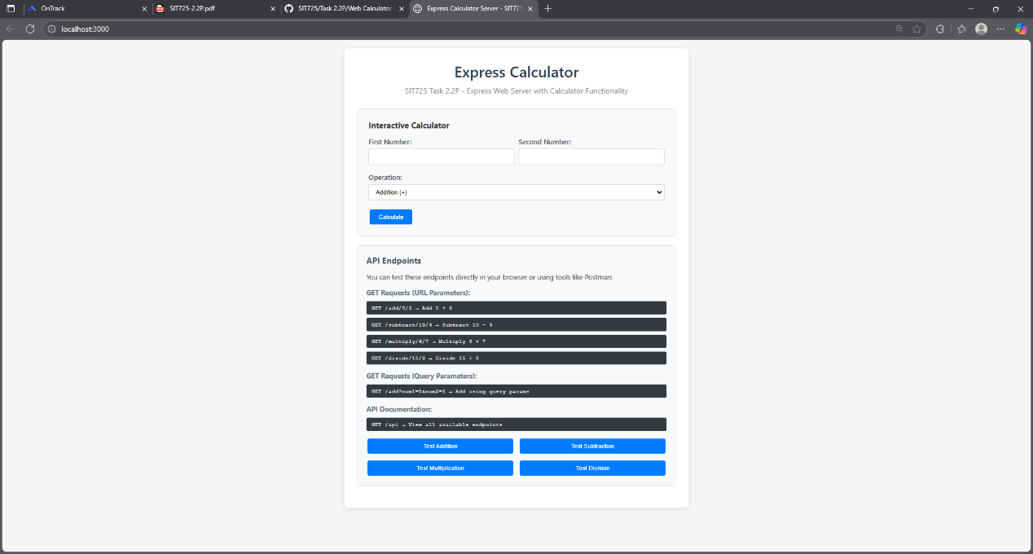

Add testing:

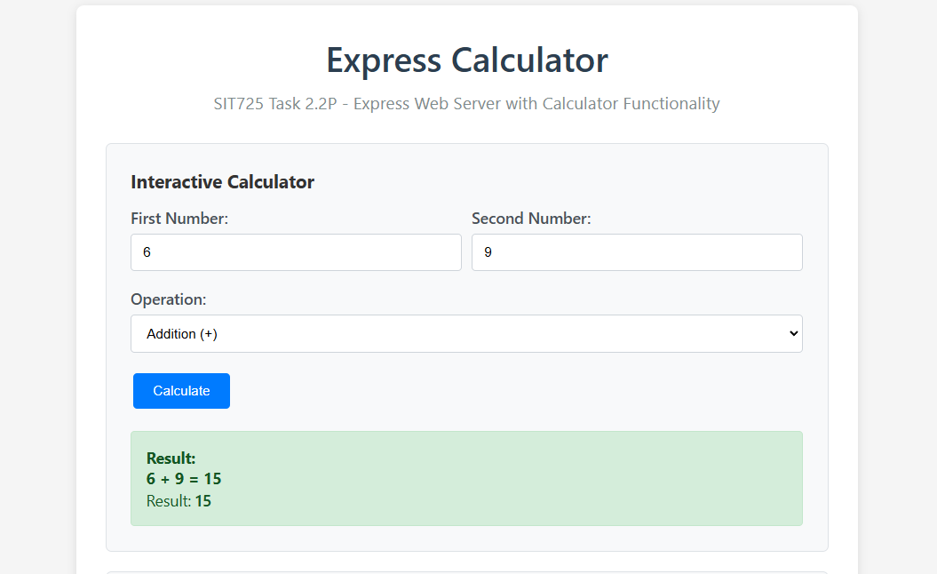

Subtraction Testing:

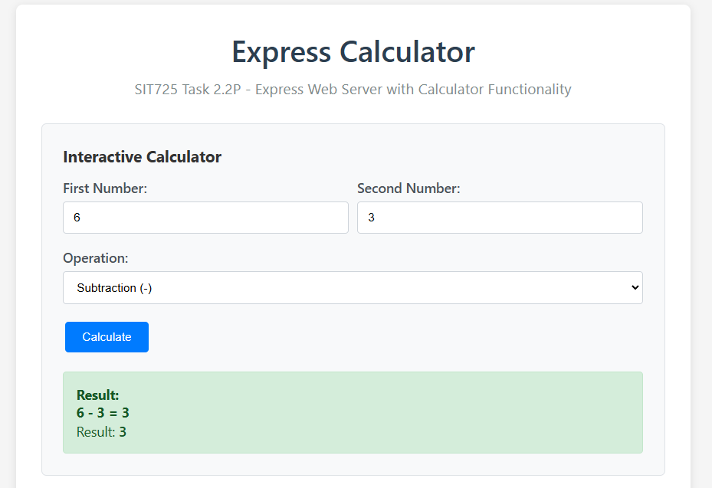

Multiplication Testing:

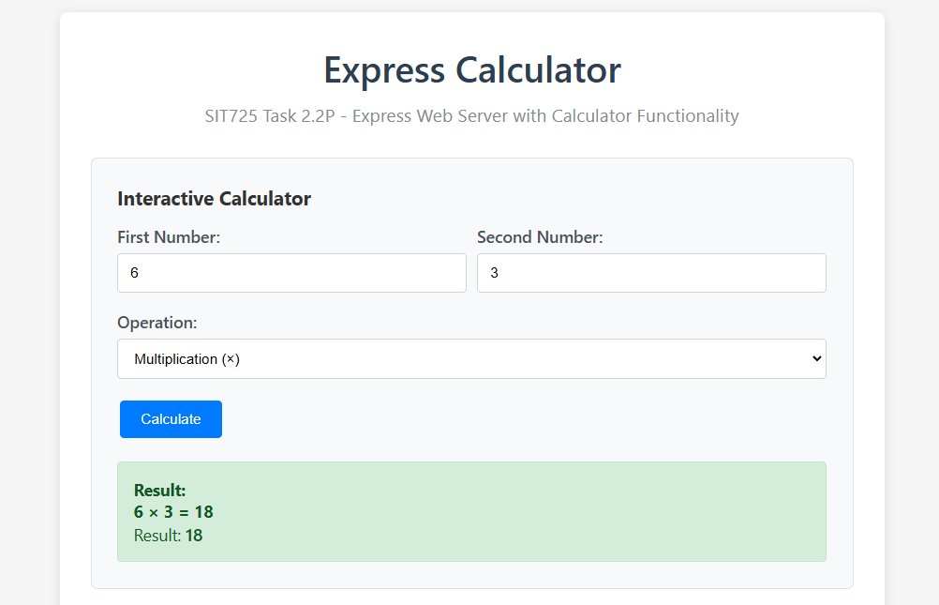

Division Testing:

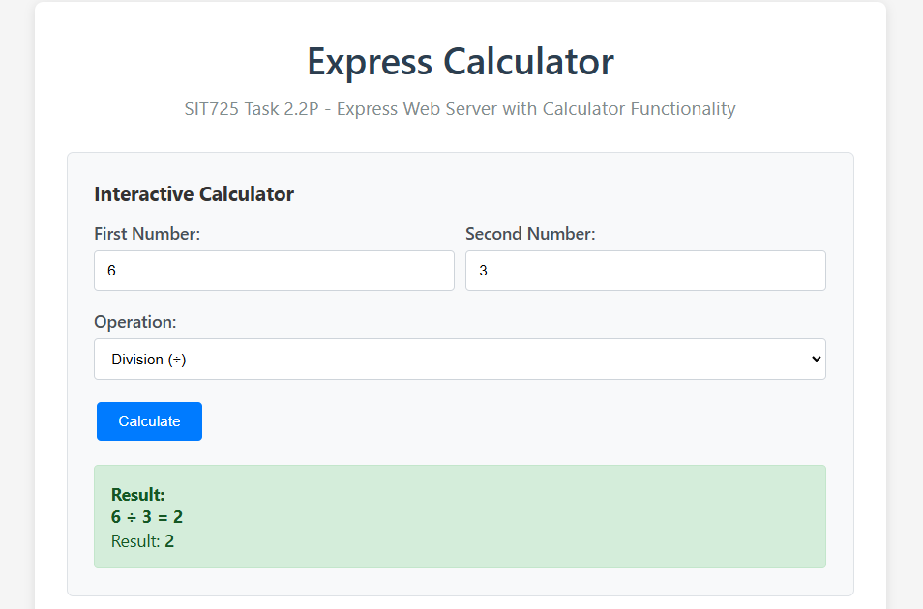

Add using query params:

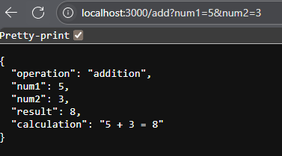

View all available endpoints:

